***Swim lane diagram***

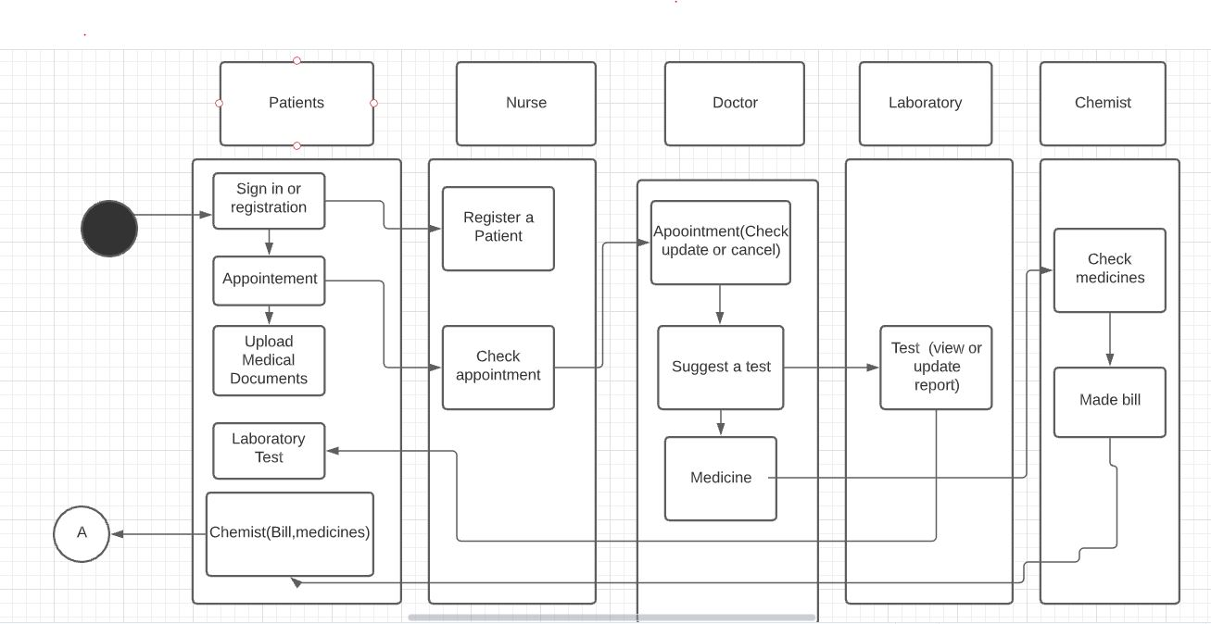

***Activity Diagram***

***Doctor***

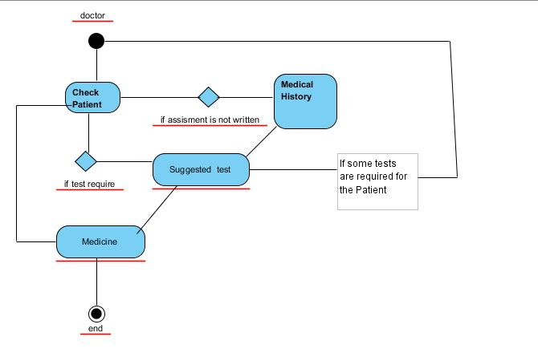

***Patient***

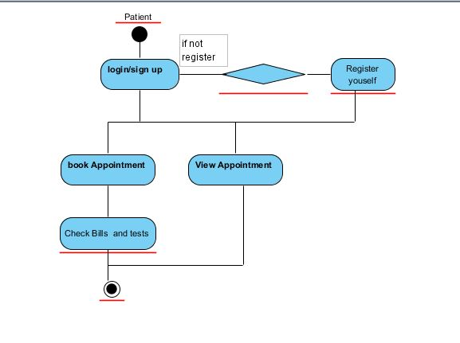

***Chemist***

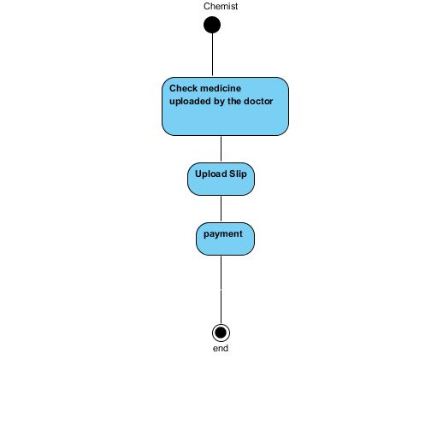

***Lab***

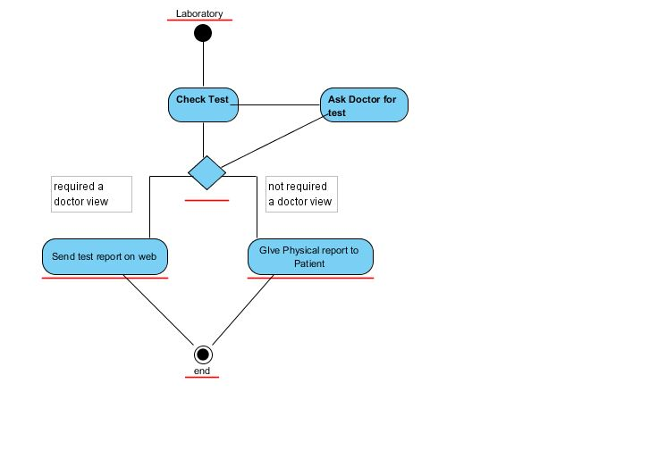

***Final Set of Requirements***

***Hospital Management System***

1. The software can register patient
2. The Software must allow to look into favorite time and book appointment
3. The software allow patient to upload form and wright the information or medical history
4. The software must allow Patient to look for doctors
5. The Patient can check the medicine recommended by doctor
6. The Patient will be able to check test
7. The Patient must have facility of online payment through any well-known services
8. The Doctor can check any Patients record
9. The doctor can suggest test and medicine for Patient
10. The Doctor is free to make any change regarding appointment
11. The lab assistant can check suggested test of specific patient
12. The lab assistant can upload test results
13. The chemist can check medicines
14. The chemist account link with online payment system